ACTIVITY AND CLASS DIAGRAM

# Activity Diagram

## Retrieve transaction API

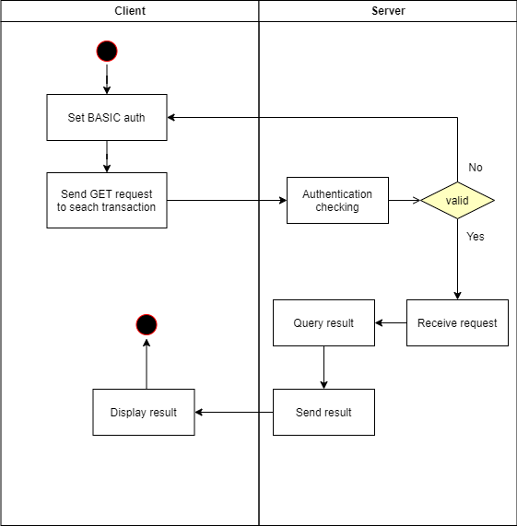

## Update transaction API

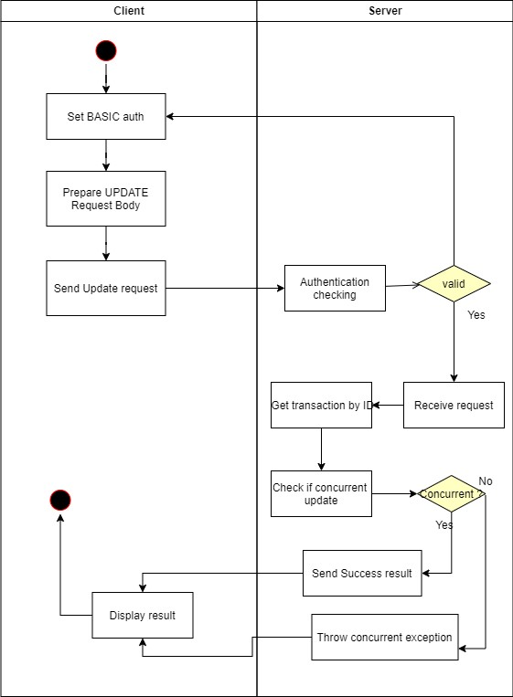

# Class Diagram

